**Project** **Report** **Template**

**1 Introduction**

**1.1 Overview**

The project aim is to provide real-time

knowledge for all the students who have basic knowledge

of salesforce and looking for a real-time project. This

project will also help to those Proffesional. Who are in

cross-technology wanted to switch to salesforce with the

include into their resume as well.

**1.2 Purpose**

This project helps in sending your travel approval

requests to your manager in place of E-Mails. With travel

approval in place, it’s easier to control how much you’re

spending on travel now and in the future.

## 2 Problem Definition & Design Thinking

### 2.1 Empathy Map

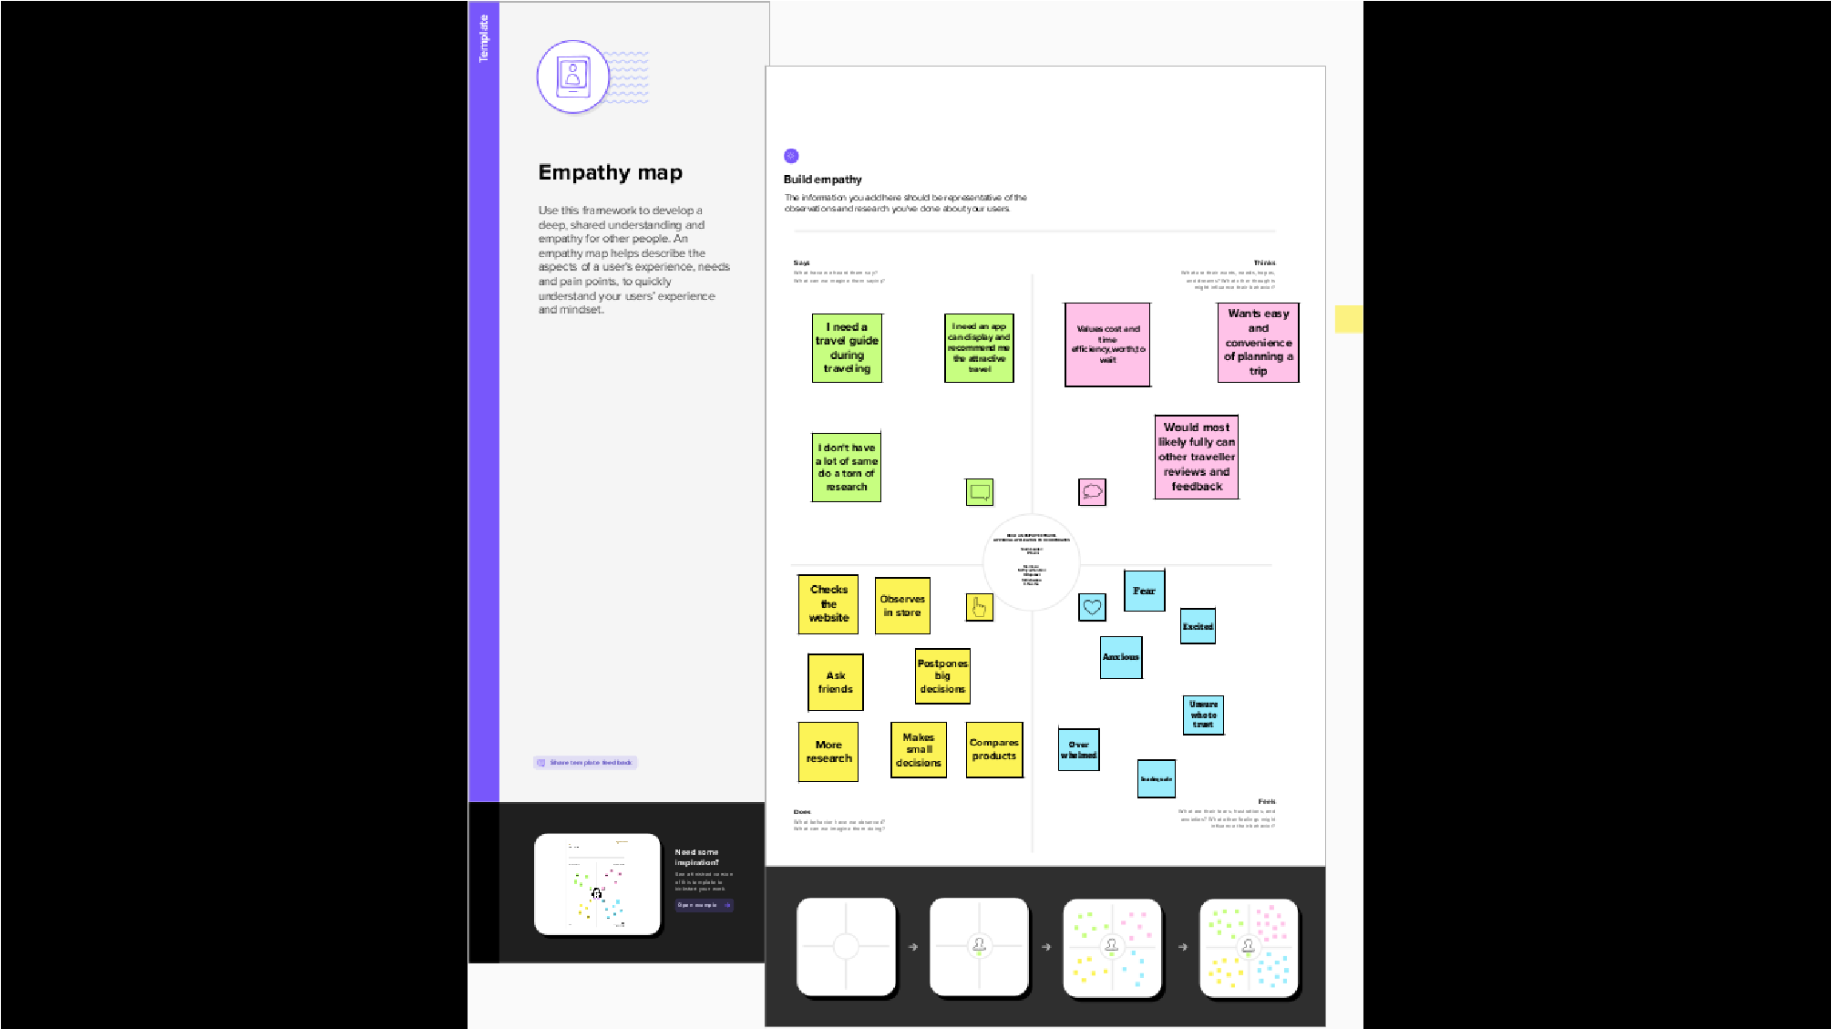

**2.2 Ideation and brainstorming map**

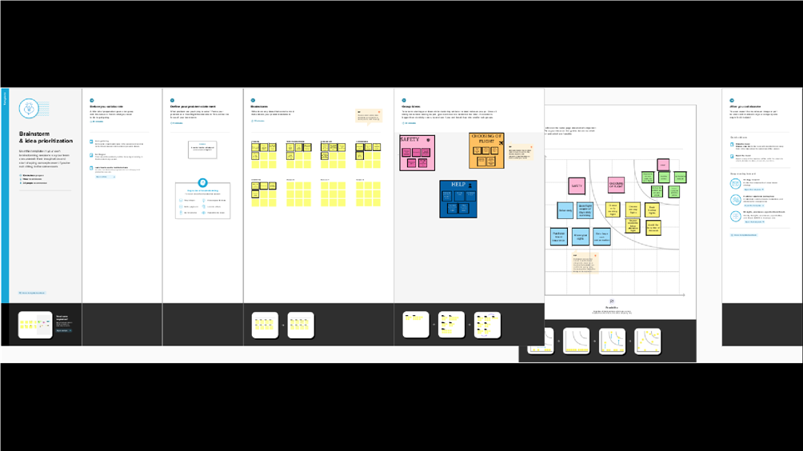

# 3 RESULT

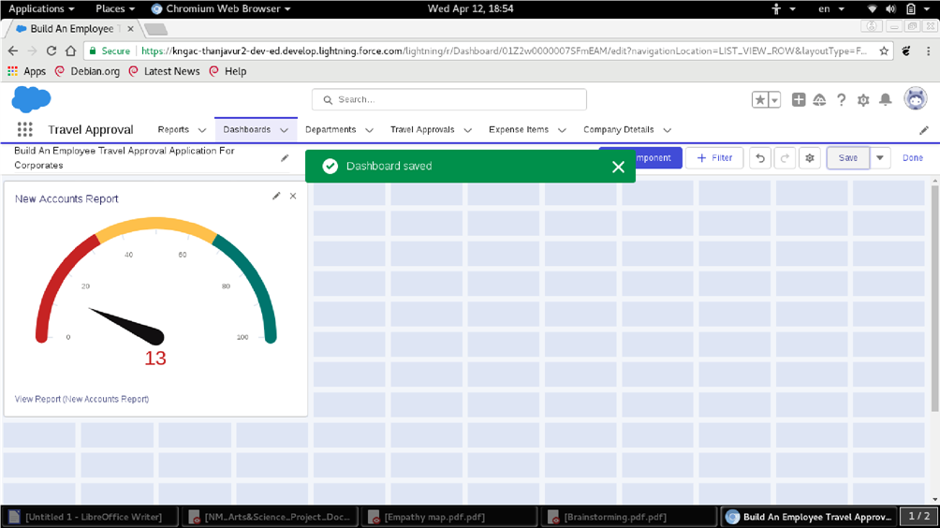

# 4 TRAILHEAD PROFILE PUBLIC URL

**Team Lead- http://trailblazer.me/id/vnila6**

**Team Member 1- http://trailblazer.me/id/pparthiban10**

**Team Member 2- https://trailblazer.me/id/kartn23**

**Team Member 3- http://trailblazer.me/id/arunk335**

**5 ADVANTAGES & DISADVANTAGES**

## Advantages :-

## • Lower cost of living

* Make new friends
* Experience new cultures
* Personal growth

***Disadvantages :***• It can be expensive

* Sickness
* It can be lonely
* Homesickness

# 6 APPLICATIONS

[A bout the Sample Application](https://documentation.softwareag.com/naturalONE/natONE912/core/samples/sample-travel.htm#travel-about)

[•Prerequisites](https://documentation.softwareag.com/naturalONE/natONE912/core/samples/sample-travel.htm#sample-travel-prereq)

[•Installing the Sample Application](https://documentation.softwareag.com/naturalONE/natONE912/core/samples/sample-travel.htm#sample-travel-install)

[•Defining the Use of an External Web Browser](https://documentation.softwareag.com/naturalONE/natONE912/core/samples/sample-travel.htm#sample-travel-extweb)

[•Starting the Sample Application](https://documentation.softwareag.com/naturalONE/natONE912/core/samples/sample-travel.htm#sample-travel-start)

[•Logging in as an Employee for Requesting a Business](https://documentation.softwareag.com/naturalONE/natONE912/core/samples/sample-travel.htm#sample-travel-logine)

[Trip](https://documentation.softwareag.com/naturalONE/natONE912/core/samples/sample-travel.htm#sample-travel-logine)

[•Entering a Travel Request with Flight and Hotel](https://documentation.softwareag.com/naturalONE/natONE912/core/samples/sample-travel.htm#sample-travel-request)

[Information](https://documentation.softwareag.com/naturalONE/natONE912/core/samples/sample-travel.htm#sample-travel-request)

[•Adding Additional Expenses to Your Travel Request](https://documentation.softwareag.com/naturalONE/natONE912/core/samples/sample-travel.htm#sample-travel-expenses)

[•Logging in as a Manager for Approving Travel](https://documentation.softwareag.com/naturalONE/natONE912/core/samples/sample-travel.htm#sample-travel-loginm)

[Requests](https://documentation.softwareag.com/naturalONE/natONE912/core/samples/sample-travel.htm#sample-travel-loginm)

[•Approving a Travel Request](https://documentation.softwareag.com/naturalONE/natONE912/core/samples/sample-travel.htm#sample-travel-approve)

## 7 CONCLUSION

Many people are not privileged enough to do that. Those who do get the chance, it brings excitement in their lives and teaches them new things. No matter how a travelling experience may go, whether good or bad, it will definitely help you learn.

# 8 FUTURE SCOPE

Travel app field involves hospitality management, trip management etc. It has endless job opportunities in India as large number of heritage, cultural and other tourists throng the country every year.